**Adding a Chrome OS Environment**

Chrome OS endpoint monitoring for Goliath Performance Monitor requires integration with [Google Chrome Enterprise](https://chromeenterprise.google/os/upgrade/?utm_source=google&utm_medium=cpc&utm_content=7014M000002BZGPQA4&utm_term=enterprise%20chrome%20management&gclid=CjwKCAjwhNWZBhB_EiwAPzlhNjYciIn9wJ8P7eQX1DhJWFaCxydhpbXKaLlVMyotG0JZQSd4Bih_eRoCA2YQAvD_BwE&gclsrc=aw.ds). Chrome Enterprise is an upgrade available from Google that allows you to manage all of your Chrome OS devices in your environment from your Google Admin portal.

Once connected to Goliath, your Chrome OS devices (Chromebooks) are added to Goliath's inventory for endpoint performance monitoring as well as integration with your Citrix session metrics for troubleshooting end user experience issues. Note: for integration with Citrix session, each Chrome OS endpoint must have a unique AssetID. Refer to Google documentation for details.

To add a Chrome OS environment to Goliath Performance Monitor, each step in this document must be completed, in order.

1. **Locate your Google Admin Customer ID**
2. **Enable Chrome APIs**
3. **Create a Service Account and Private Key File**
4. **Manage Domain Wide Delegation**
5. **Create a New Admin Role**
6. **Add Chrome OS Environment to GPM**

**STEP 1: Locate your Google Admin Customer ID**

1. Log in to your Google Admin account.
2. In the main menu, go to **Account > Account Settings**.
3. The Customer ID is displayed in the Profile section on the right.  
   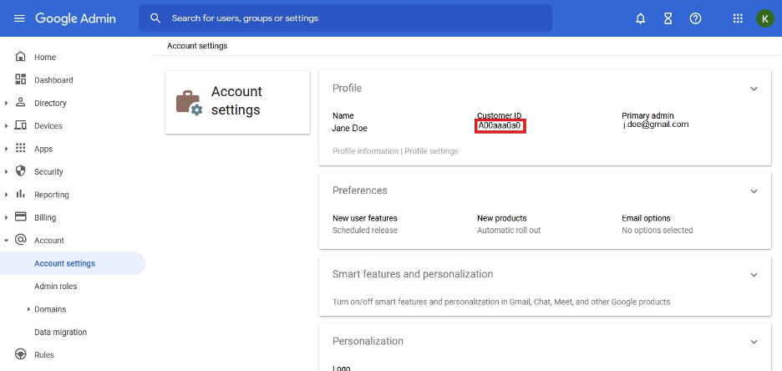

**STEP 2: Enable Chrome APIs**

1. Log in to Google Cloud Platform (console.cloud.google.com).
2. In the main menu, go to **APIs & Services** > **Enabled APIs & Services.  
   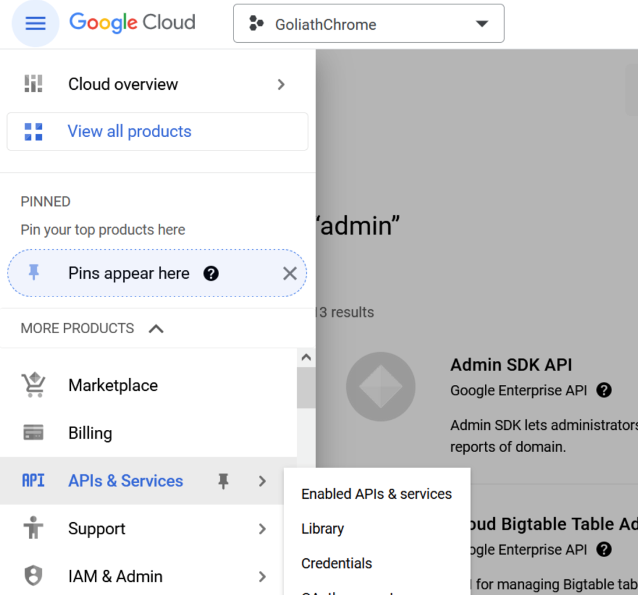**
3. Click **+ Enable APIs and Services** at the top of the page.  
   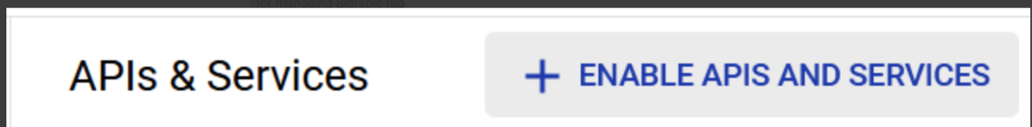
4. Search for "Admin SDK API".  
   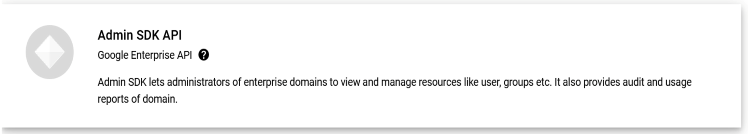
5. Select **Admin SDK API** and then click **Enable.  
   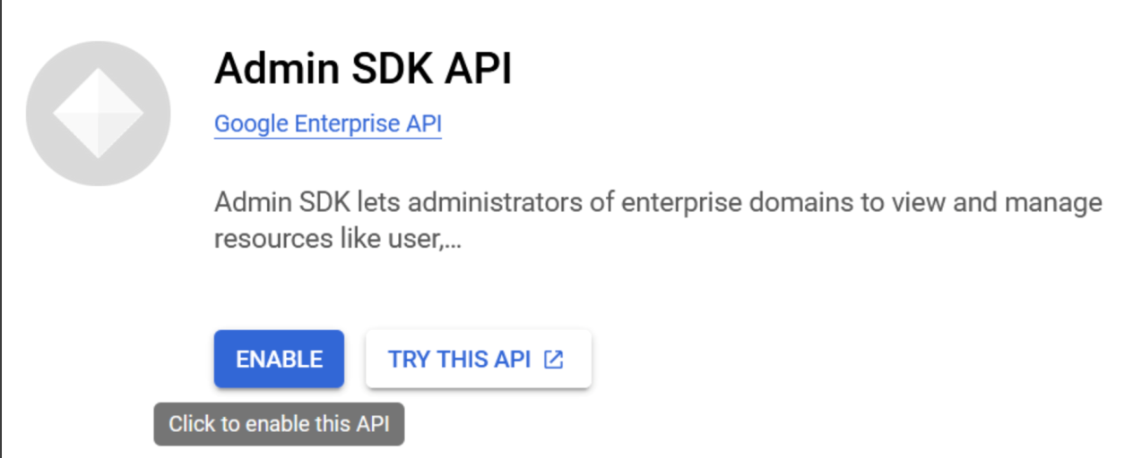**
6. Next search for "Chrome Management API".  
   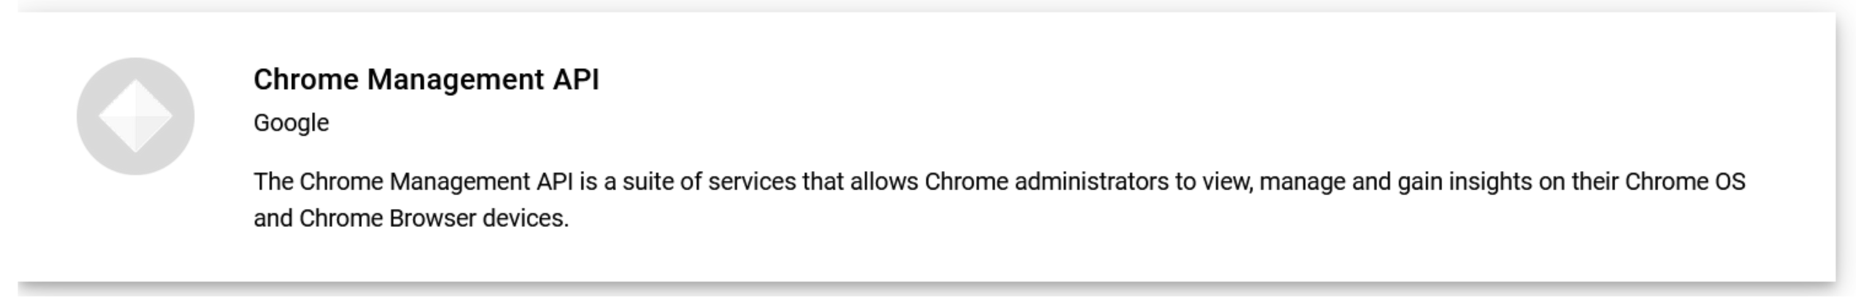
7. Select **Chrome Management API** and then click **Enable.  
   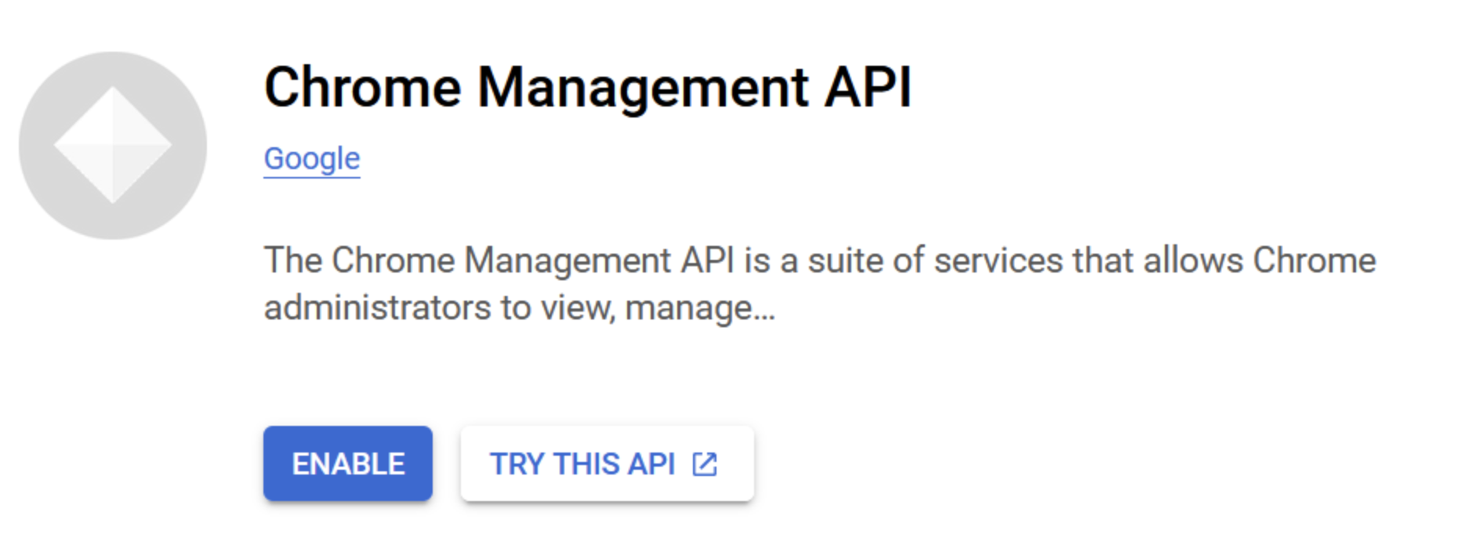**

**STEP 3: Create a Service Account and Private Key file**

1. Within Google Cloud Platform go to **Credentials.**
2. Click **+ Create Credentials**then click **Service Account.  
   Note:** If you do not see Create Credentials option, you may need to first create a project. Create a Project by clicking **Create Project,** provide a project name, then click **Create.  
     
   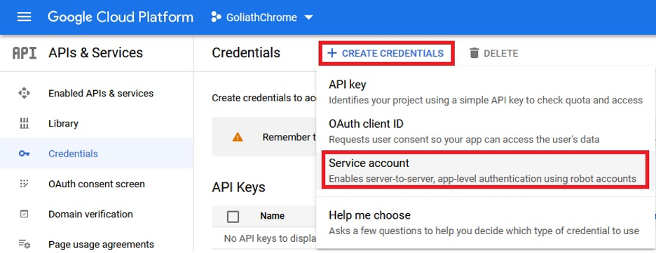**
3. Input a Service account name (enter any name you wish) and select **Grant this service account access to projects**.  
   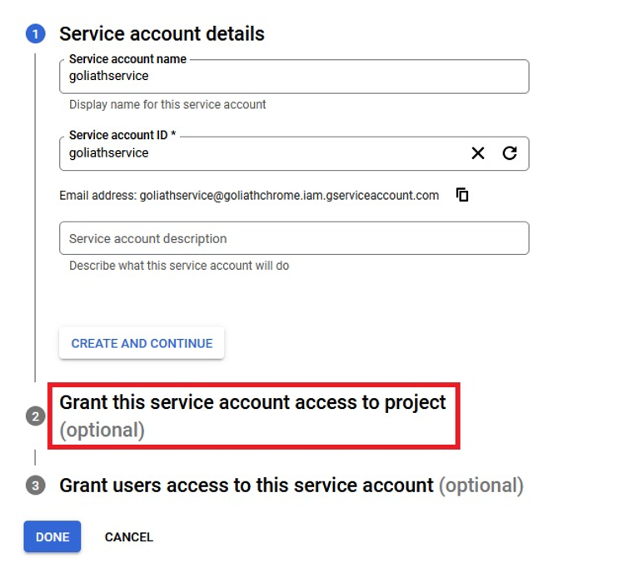
4. In the **Select a role** dialog, under **Quick Access,** select **Basic** then **Viewer**.  
   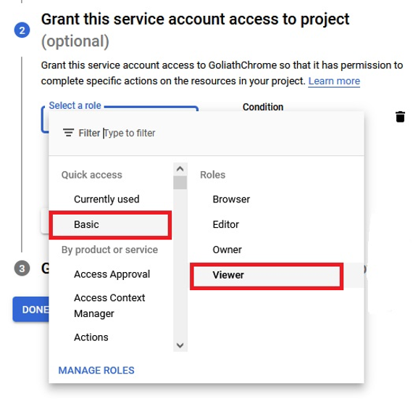
5. Click **Done** and ensure there is a value for **Unique ID**. You will need this in the next section below. Also ensure there is a value for **Email** as you will need this when creating the Admin Role later.  
   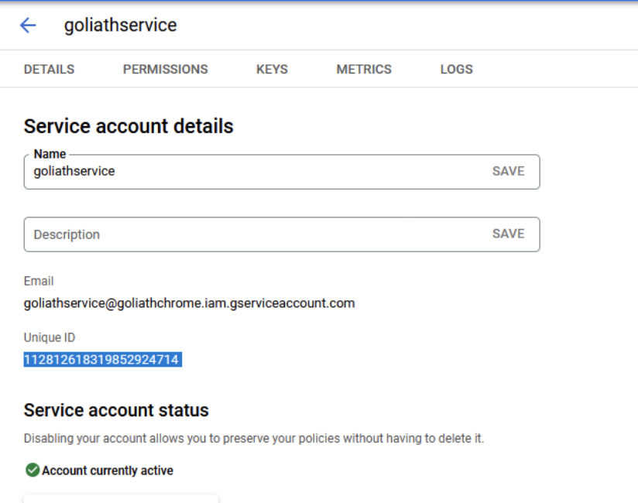
6. Next, click the service name you just created, then click the **Key**tab at the top of the page.
7. Click **Add Key.**
8. In the dialog that opens, select **Create new key.  
   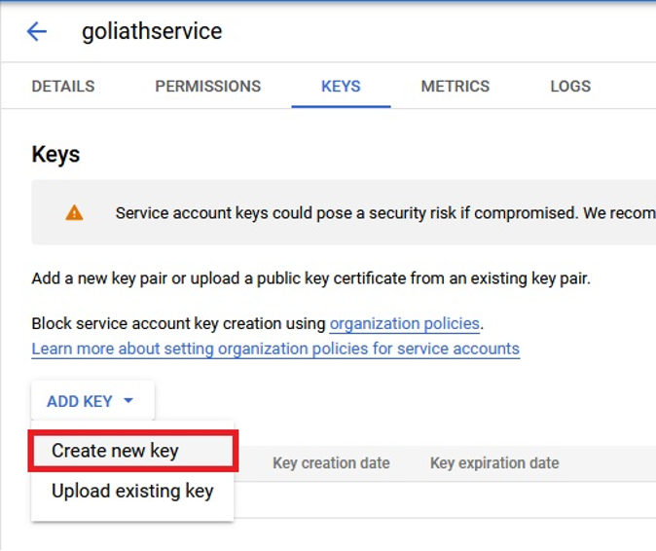**
9. For **Key type,**select **JSON**, then click **Create.**
10. The file is downloaded to your local machine. You will need this file later when adding the environment to Goliath.

**STEP 4: Manage Domain-Wide Delegation**

1. Log in to your Google Admin account.
2. From the main menu, select **Security**, then **Access and data control,**then **API controls.  
   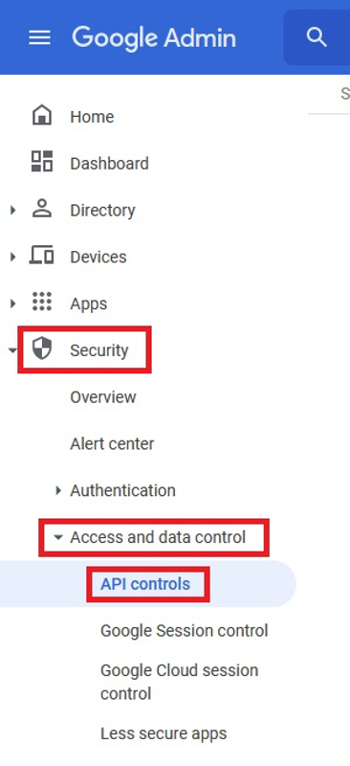**
3. Click **Manage Domain-Wide Delegation.**
4. Click **Add New.**
5. In the **Client ID** text box, enter the **Unique ID** you created earlier in the section above.
6. In the **OAuth scopes** text box, copy and paste the following comma-delimited list of URLs:  
   <https://www.googleapis.com/auth/chrome.management.telemetry.readonly>, <https://www.googleapis.com/auth/admin.directory.device.chromeos.readonly>  
     
   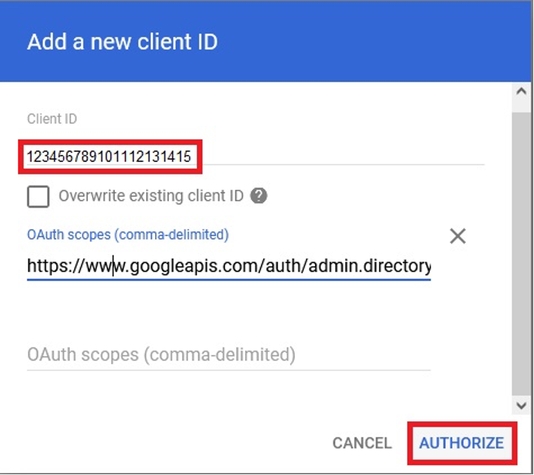
7. Finally, click **Authorize.**

**STEP 5: Create an Admin Role**

1. Log in to your Google Admin account.
2. From the main menu, select **Account** then select **Admin roles.  
   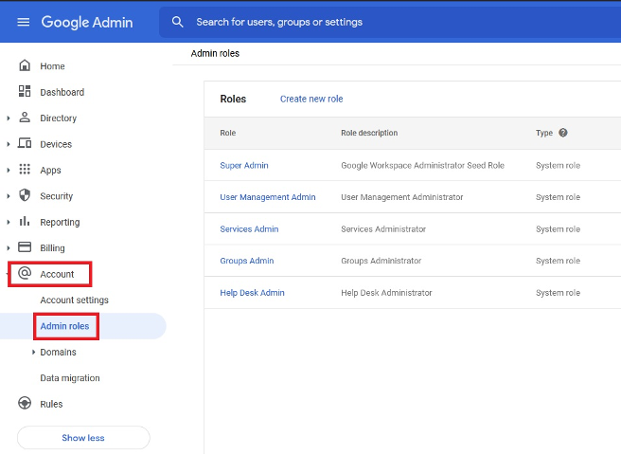**
3. Click **Create new role.**
4. In the **Role** **info** step, enter *Chrome Management* into the Name text box, then click **Continue**.  
   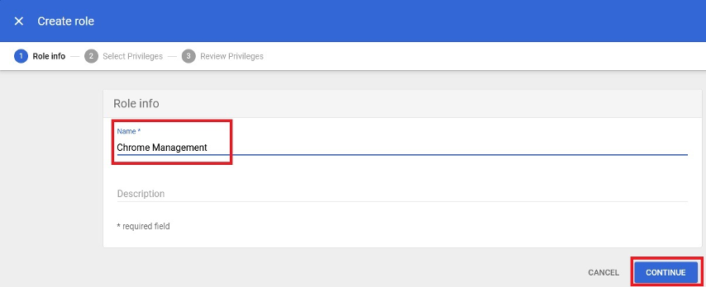
5. At the **Select Privileges**step, scroll down to select the **Manage Chrome OS Devices (read only)** below the **Manage Chrome OS Devices** option.  
   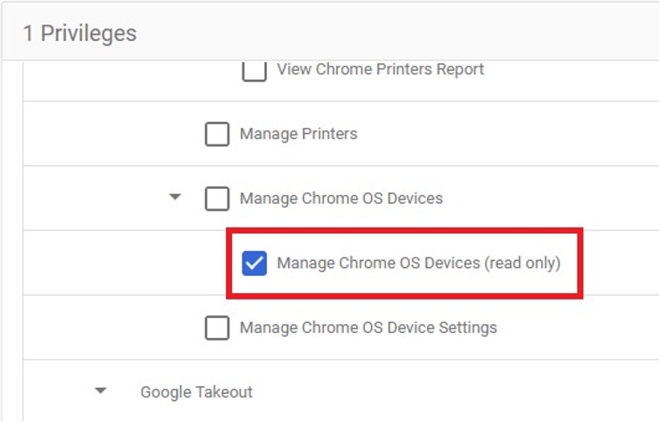
6. Click **Continue** and then click **Create Role.**
7. Within the **Roles** table, mouse over the newly created Chrome Management role and click **Assign Admin** option**.  
   **
8. In the dialog that opens, click **Assign service accounts**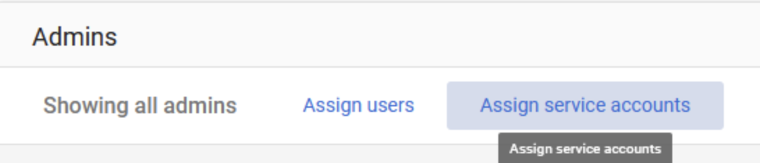
9. In the **Add service accounts,** enter the Email address of the **service account** you created earlier and click **Add.**  
   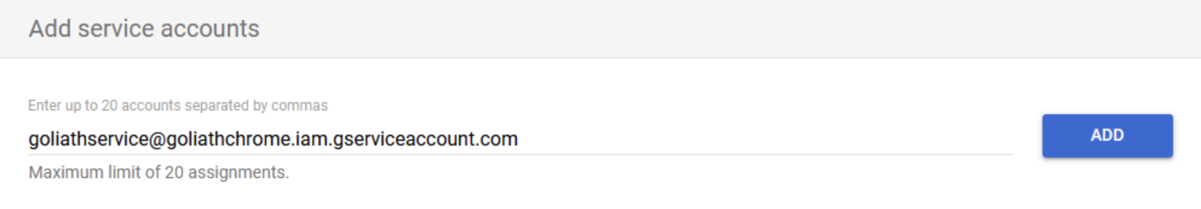

**STEP 6: Enable Citrix Workspace Integration Policy**

1. In the **Google Admin** console, select **Devices > Chrome > Apps & extensions > Users & browsers**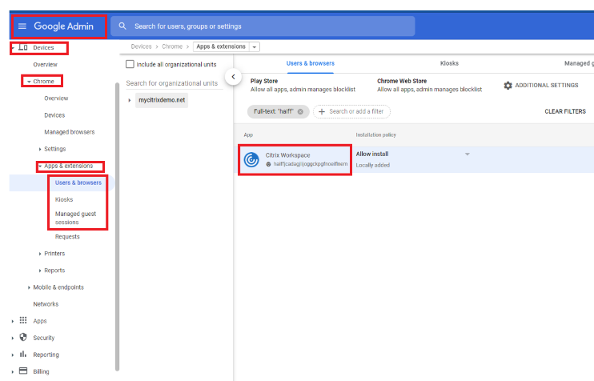
2. Search for Citrix Workspace app
3. Click the Citrix Workspace app icon
4. The policy for extensions appears. Upload the JSON file created in **Step 3**
5. Click Save

**STEP 7: Add the Chrome OS Environment to GPM**

1. Log in to Goliath Performance Monitor Server and click **Settings**.
2. Select **Manage** **Environments** and then click **+Add**.
3. In the dialog that opens enter:
   1. **Display Name**: this can be any text string to identify the environment.
   2. **Customer ID**: from your Google Admin account (see above).
   3. Upload the Private Key JSON file you created using the options provided.
4. Click **Save**.
5. The environment is added to GPM and is displayed within the Environment table.  
   Your Chrome OS devices will populate into the **Inventory** and **Status** pages and, if using GPM to monitor Citrix, Chrome OS endpoint metrics will be displayed within your Citrix session metric dialogs.

**Note:** It can take up to one hour before data is updated within your environment. This is a known limitation of the Google Chrome OS APIs.

**Integrating Chrome OS Devices with Citrix Data**

To associate your Citrix sessions to Chrome OS endpoints, each Chrome OS device must have a unique AssetID. This is set in the Google Admin console.

